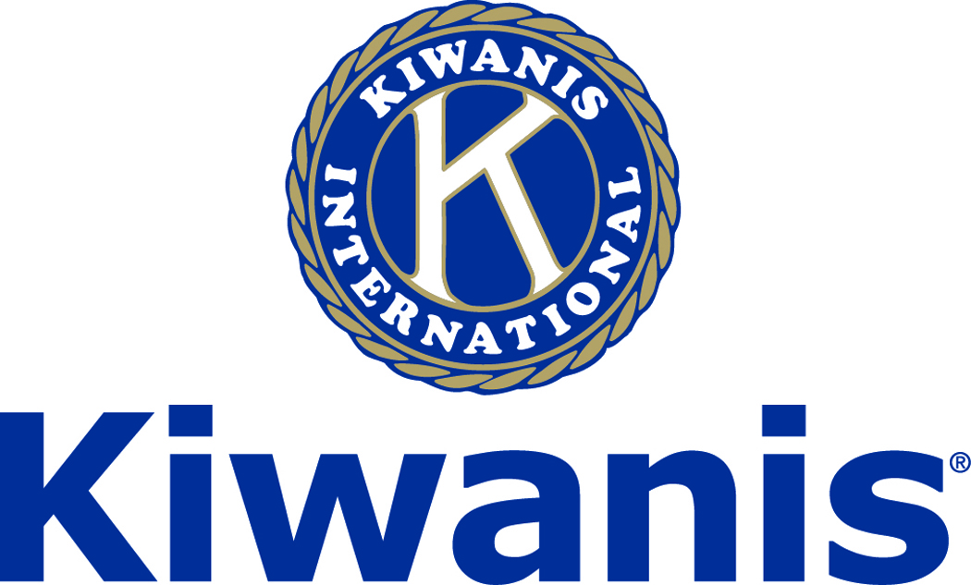
Club of Las Vegas
Week of:
September 3 2017

http://www.kiwaniscluboflasvegas.org/

******************************************************************
Win a free lunch!
Read this newsletter for details

******************************************************************

SPEAKER for September 6 MEETING:
Brook Demitropoulos

Brook will be speaking about Kids and K-6 learning activity

Networking: 11:45am. Meeting: 12:15 to 1:15pm.

Wednesday’s, Marie Callender's, 8175 West Sahara,
Lunch ($20) and includes a slice of pie.

******************************************************************
Coming SOON!
YOUR 2017-2018 DUES
Your 2017 2018 dues bill will be emailed to you this week and we are asking that you reply no later than September 29th

Questions contact:
Ken Tracht or John Case

******************************************************************

Save your POP-TABS to benefit
Ronald Mc Donald House

If you have pop tabs to donate contact Len Yelinek.

******************************************************************

Thank You
for using Amazon-Smile and selecting Kiwanis Club of Las Vegas Foundation as your charity when you make purchases.

When you do Amazon donates to
Kiwanis Club of Las Vegas Foundation
So far this year we’ve received $129.29

Please Use smile.amazon.com and Amazon will donate to Kiwanis Club of Las Vegas Foundation. Sign up with Amazon Smile and designate the Kiwanis Club of Las Vegas Foundation as your charity. Amazon will donate 0.5% of the price of your eligible Amazon Smile purchases to Kiwanis Club of Las Vegas Foundation whenever you shop on Amazon Smile. Amazon Smile is the same Amazon you know. Same products, Same prices, Same service. Use the link below and you will be directed to great gift ideas and help support your Kiwanis Club of Las Vegas Foundation.
AmazonSmile click here: smile.amazon.com/ch/86-0850741

*******************************************************************
Get ready to help!

UMC is hosting a Halloween Saft-tacular!
See Erica Nansen or Len Yelinek for more information
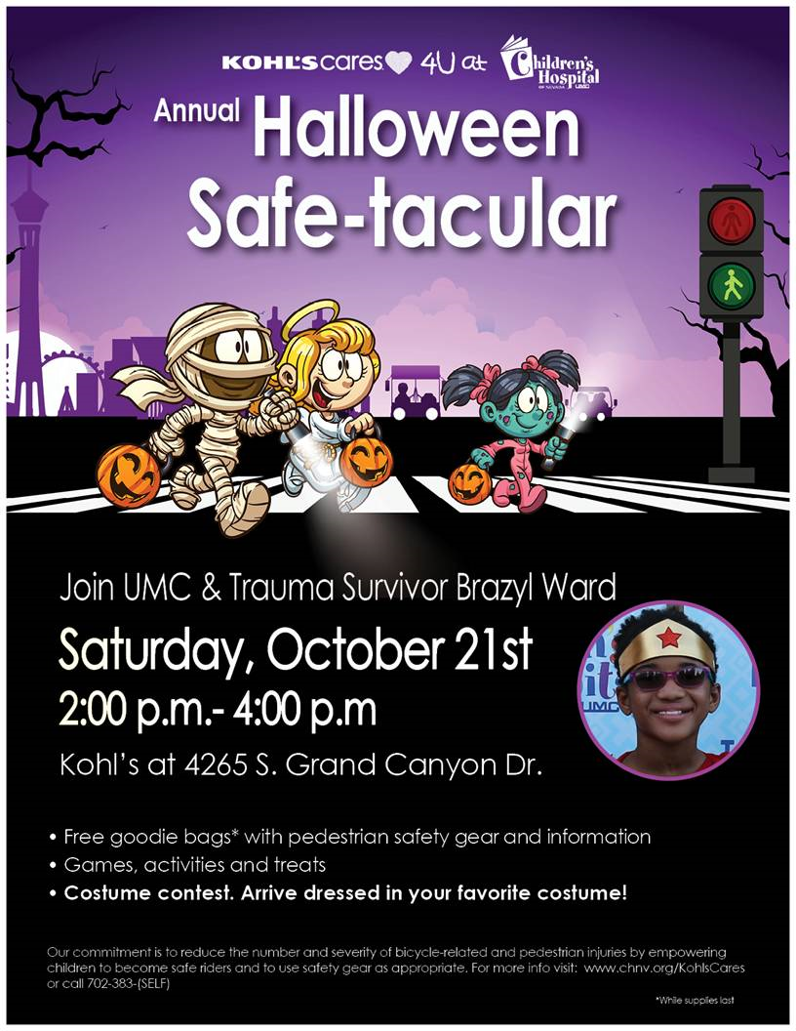
******************************************************************

FREE LUNCH!

Each week we hold a random drawing
and one of our members wins a free lunch, including a slice of pie, redeemable at one of our next three regular meetings.

Congratulations’
>>>> Paul Trenshaw <<<<
You won a FREE Lunch

Redeem your free lunch at one of our next three meetings
Sept 6th, 13th or 20th meeting!
See you there!

******************************************************************
Service Hours
Be sure to turn in your service hours to Nancy Sapling
Fill out the form at our weekly lunches or
Email your service hours to Nancy at: Nancy.Sapling7@gmail.com

******************************************************************

Donate to the
Kiwanis Club of Las Vegas Foundation

Help us fund our programs with your tax deductible donation to our Kiwanis Club of Las Vegas Foundation

******************************************************************

UPCOMING September 2017 EVENTS:

September 6: - Brook Demitropoulos on Kids and K-6 learning activity

September 13: - The Make-a-Wish Foundation

September 20: - Dan Campbell, Principal Structural Engineer

September 27: - Courtney Dufford about Nevadans for the Common Good

*******************************************************************

For club information Log onto our Web Site!
http://www.kiwaniscluboflasvegas.org/

contact Jerry McElroy or Howard Naylor
with additions or corrections

*******************************************************************

