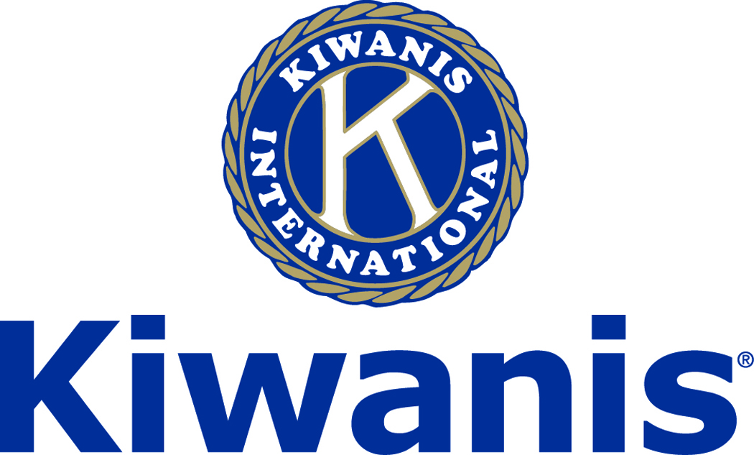

**Club of Las Vegas**

**Week of:**

***November 4, 2018***

**Special Request!**

**For Kiwanis Club of Las Vegas Members “Backup Singers” needed for the DCM**

**See Howard this week**

[**http://www.kiwaniscluboflasvegas.org/**](http://www.kiwaniscluboflasvegas.org/)

***[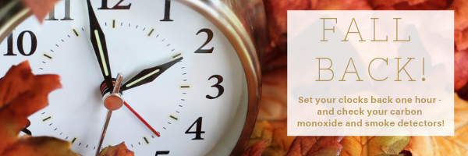](http://r20.rs6.net/tn.jsp?f=001c9HbzubK9PuaW_f3pgHUTTmWpETwifHka9Rxpshx7tQX2JD7Zbiyk6-8WtNfATZKgvt-HUH2GdEEDC57kXN9PAWi9Y_HKvd4OCYiYPE_5ah7y9ZRHMTrPFKUqbV9QWVg6Zu2E1dHkpHM_wuienM523bOqKQnQYr6A-n9dl0Pvep9bnrQknKQuBA-vWuXHyDlDZ8TRNxRB40=&c=_4_gDtSTGsGbTV8A5GO4qUOjsObj4rUZd5dWY4O1cOCTVXjcH0PJHg==&ch=c2NOtCO-EEsEFjRQ3cEZqBnQGZzaNn3InSrpG6FzBJd6AeF_6qKsoQ==)***

******************************************************************

**SPEAKER for November 7th MEETING:**

**Michael Hall**

**The Atomic Testing Museum**

**Networking: 11:45am. Meeting: 12:15 to 1:15pm.**

**Wednesday’s, Marie Callender's, 8175 West Sahara,**

**Lunch ($20) and includes a slice of pie.**

******************************************************************

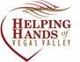

The Kiwanis Club of Las Vegas will be assisting Helping Hands of Vegas Valley in reading letters for the **Walker Furniture Home for the Holidays program** on

Tuesday, November 13th, from 9 a.m. till 11 a.m.

The reading will be at:

The Helping Hands of Vegas Valley offices

2320 Paseo Del Prado (Suite B-204),

Las Vegas, NV  89102.

Sign up at our November 7th luncheon meeting.

******************************************************************

**Varsity Quiz**

This is the third week of division competition for the 50th season of **Varsity Quiz**. The Varsity Quiz Program is patterned after a high school program that was being sponsored by the Kiwanis Club of Greater Anaheim. In 1969 a delegation from that club convinced the leadership of the Kiwanis Club of Las Vegas to sponsor a similar program in Clark County.  The Southern Nevada program was named Varsity Quiz. It is conducted within the Clark County School District (CCSD).  The Varsity Quiz Program is a partnership between the Kiwanis Club of Las Vegas, CCSD, and Vegas PBS TV-10.

**Varsity Quiz Question of the Week**

**Do you know the answer to this question?**

**What is the shape of a lens that diverges a wavefront?**

**(the answer will be in next week’s newsletter)**

***Last week’s question and answer.***

**What massive arch has become an architectural symbol for the city of St. Louis?**

**Answer: Gateway Arch**

******************************************************************

***Get a FREE lunch!***

***read this newsletter for details***

******************************************************************



**64th Annual Kiwanis/Rotary Thanksgiving Food Drive lunch November 21st**

**RSVP and Pre-Pay $30 today**

**Please, cash or check only no credit cards**

******************************************************************

**64th ANNUAL KIWANIS/ROTARY THANKSGIVING FOOD DRIVE LUNCH**

DATE:      WEDNESDAY, NOVEMBER 21, 2018

TIMES:      ARRIVAL - 11:30am   MEETING - 12:15pm

LOCATION:   LAWRY's PRIME RIB @ E. FLAMINGO AND 4043 HOWARD HUGHES PARKWAY

COST:      **$30.00, cash** or **check** payable to **KIWANIS CLUB OF LAS VEGAS**

**RESERVATIONS:   Please RSVP and Pre-PAY BY WEDNESDAY, NOVEMBER 14th**

PLEASE NOTE:     The submission date is set by Lawry's for planning purposes.  Our club will be charged for that number regardless of no-shows. Please cancel before the 14th, as we must bill no-shows to cover costs.

**DONATIONS: Make checks out to THE SALVATION ARMY, a 501(c)(3) charitable organization.  Cash is also acceptable. Give your donation to the Kiwanis person at the check-in desk. If cans are donated, deliver to a Kiwanis rep inside the Lawry's entrance by Noon**.

SPEAKER:    UNLV Women Basketball Coach Kathy Oliver and some of the Lady Rebels will be joining her.

******************************************************************

**NEXT WEEK, November 14th**

**Join us for Operation Christmas Child Holiday Project Meeting.**

**Remember to bring your items to fill the Christmas Shoebox’s**

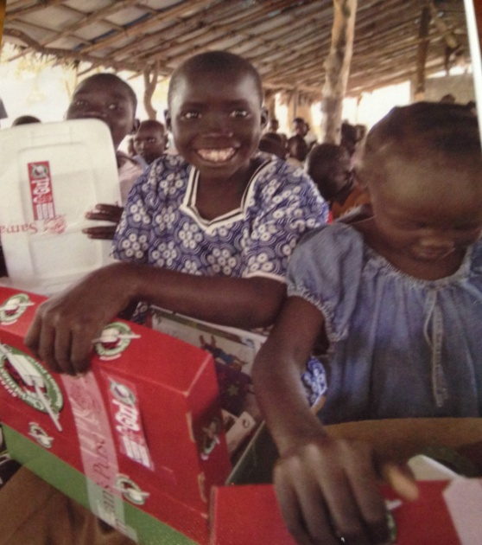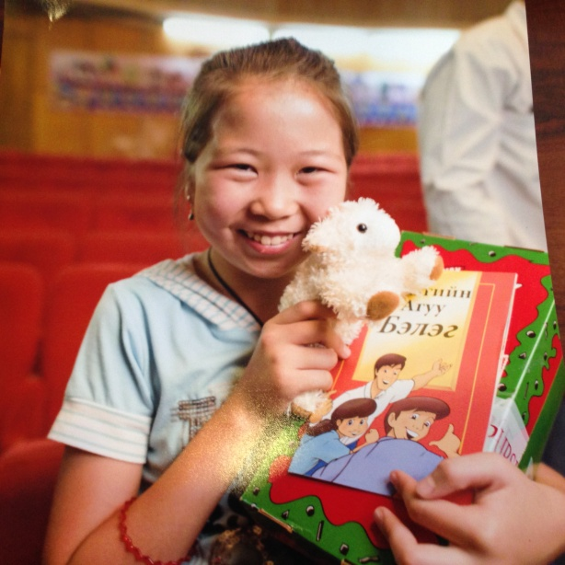

**Since 1993 Operation Christmas Child, a project of Samaritans Purse has sent 1O3 million shoeboxes filled with gifts to children in need around the world. Each box is filled with school supplies, toys, hygiene items (no liquids please) that will bring smiles to the faces of children who live in poverty, orphanages, and or storm ravaged countries**.

******************************************************************

***Save your POP-TABS to benefit***

***Ronald Mc Donald House***

***If you have pop tabs to donate contact Len Yelinek.***

******************************************************************

**Donate to the**

***Kiwanis Club of Las Vegas Foundation***

**a 501(c)(3) charitable organization**

**Help us fund our programs with your tax deductible donation to our Kiwanis Club of Las Vegas Foundation**

******************************************************************

***Please Use Amazon-Smile***

The Kiwanis Club of Las Vegas Foundation just received a $13.60 donation from the AmazonSmile Foundation as a result of AmazonSmile program activity between April 1 and June 30, 2018.

You can help increase our donations by using AmazonSmile and selecting “Kiwanis Club of Las Vegas Foundation” as your charity.

**When you order at Amazon-Smile, Amazon donates to**

**Kiwanis Club of Las Vegas Foundation**

**This Kiwanis year we’ve received $58.52**

**Select Kiwanis Club of Las Vegas Foundation as your charity when making your purchases.**

**Use** [**smile.amazon.com**](https://smile.amazon.com/gp/r.html?C=7HYU8Y4EZWZW&R=2OM74E2TQH61W&T=C&U=http%3A%2F%2Fsmile.amazon.com%2Fgp%2Fcharity%2Fhomepage.html%3Forig%3D%252Fgp%252Fbrowse.html%253Fnode%253D502659011%26ein%3D86-0850741%26ref_%3Dpe_732550_190307700&A=I1HQ1LDYEOQFBAICG0TGN2IDZUOA&H=SYAUSO4VGWQXCXS3JTTAWZAJXWKA&ref_=pe_732550_190307700) and Amazon will donate to Kiwanis Club of Las Vegas Foundation. Sign up with Amazon Smile and designate the Kiwanis Club of Las Vegas Foundation as your charity. Amazon will donate 0.5% of the price of your eligible Amazon Smile purchases to Kiwanis Club of Las Vegas Foundation whenever you shop on Amazon Smile. Amazon Smile is the same Amazon you know. **Same products, Same prices, Same service**. Use the link below and you will be directed to great gift ideas and help support your Kiwanis Club of Las Vegas Foundation.

**AmazonSmile click here:** [**smile.amazon.com/ch/86-0850741**](https://smile.amazon.com/gp/r.html?C=2AU9G2CMQ9IQM&R=2OM74E2TQH61W&T=C&U=http%3A%2F%2Fsmile.amazon.com%2Fch%2F86-0850741&A=6PNWEYXALJ7J4QHW7SL1FV6DH3KA&H=HK0LAEKSGAKLH10PCQ1PHTOGAMEA)

******************************************************************

FREE LUNCH!

**Each week we hold a random drawing**

**and one of our members wins a free lunch, including a slice of pie, redeemable at one of our next three regular meetings.**

***Congratulations’***

**>>>> Vernon Bailey <<<<**

***You won a FREE Lunch***

**Redeem your free lunch at one of our next three meetings**

**Nov 7th, 14th or 21st meeting!**

*******************************************************************

**UPCOMING November 2018 EVENTS**

**November 7:** - Michael Hall, the Atomic Testing Museum  
  
**November 14:** - Carol Bubonovich, the Shoebox Packing Day  
  
**November 21:** -  Kiwanis/Rotary Thanksgiving Luncheon

**November 28:** -  Veronica Atkins, Nevada Blind Children’s Foundation

******************************************************************

**Service Hours**

**Be sure to turn in your service hours to Nancy Sapling**

**Fill out the form at our weekly lunches or**

**Email your service hours to Nancy at:** [**Nancy.Sapling7@gmail.com**](mailto:Nancy.Sapling7@gmail.com)

******************************************************************

**For club information Log onto our Web Site!**

**You can make a donation to our club on our web home page.**

[**http://www.kiwaniscluboflasvegas.org/**](http://www.kiwaniscluboflasvegas.org/)

**contact Jerry McElroy or Howard Naylor**

**with additions or corrections**

******************************************************************