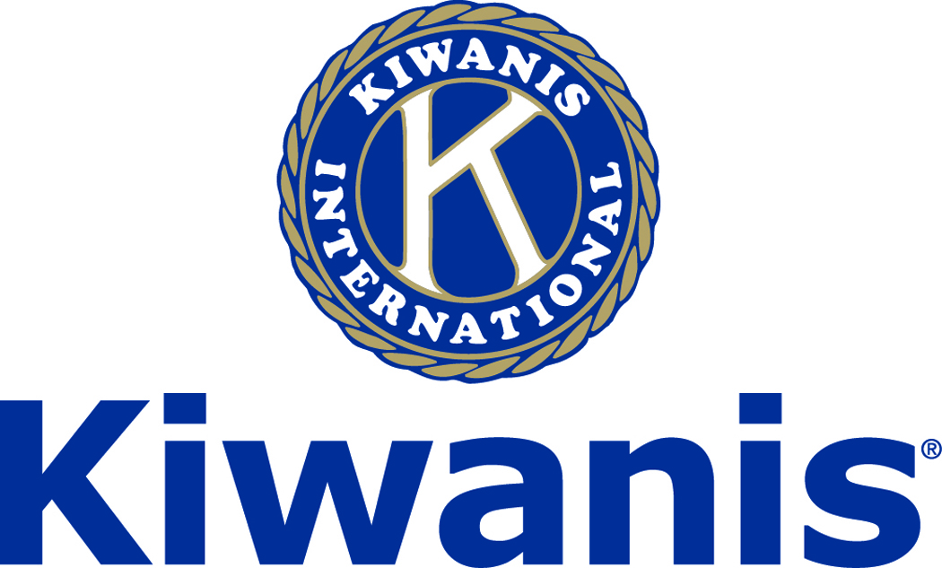

Club of Las Vegas

Week of:
May 5, 2019

http://www.kiwaniscluboflasvegas.org/

******************************************************************

Watch Varsity Quiz Monday May 6th 7:30PM on KLVX TV-10 “Vegas PBS”

******************************************************************

KIWANIS CLUB OF LAS VEGAS
E-Mail Silent Auction

The Kiwanis Club of Las Vegas has received two tickets ($90+ value) for the Las Vegas Aviators May 13th game and two tickets for May 14 Aviators game These tickets will be awarded to the person(s) making largest donation to the Kiwanis Club of Las Vegas Foundation
Tacoma Rainiers vs Las Vegas Aviators
SEC: 113 Row C Seats 3 & 4
Monday May 13th and/or May 14th

First
Win (2) tickets to the Aviators May 13th 7:05PM game
Includes VIP Parking pass.
Two tickets ($90+ value) could be yours!
CURRENT HIGH BID $100
Second
Win (2) tickets to the Aviators May 14th 10:35AM game
Includes VIP Parking pass.
Two tickets ($90+ value) could be yours!
CURRENT HIGH BID $20

Just reply to this e-mail with your bid!

To see the current “high-bids” log onto:
www.kiwaniscluboflasvegas.org

Reply NOW to this e-mail with your bid!

Be sure to indicate the game you’re bidding on.

Donation to the Kiwanis Club of Las Vegas Foundation

Tickets donated by a member of Kiwanis Club of Las Vegas

Winning bids will be announced
at our meeting Wednesday May 8th 2019

******************************************************************

2019-2020
Kiwanis Club of Las Vegas
Annual Elections

Be sure to attend Wednesday, May 22nd Kiwanis Club of Las Vegas meeting. This will be our annual meeting for elections for the Kiwanis Club of Las Vegas and the Kiwanis Club of Las Vegas Foundation.

If you are interested in becoming an officer or director, please contact: Ken Tracht 702-870-1166

******************************************************************

SPEAKER for May 8th MEETING:

Jordan Rincon
Las Vegas Lights Major League Soccer

Networking: 11:45am. Meeting: 12:15 to 1:15pm.

Wednesday’s, Marie Callender's, 8175 West Sahara,
Lunch ($20) and includes a slice of pie.

******************************************************************

Get a FREE lunch!
Read this newsletter for details

******************************************************************

Kiwanis Club of Las Vegas
SUPER SUMMER THEATER

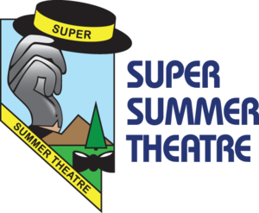
August is Super Summer Theatre time!
This year we’re going to see CHICAGO.

More information coming soon

******************************************************************

Carnival in the Clouds
Volunteers Needed!

Carnival in the Clouds is a FREE family festival celebrating flight with a focus on Drones. Event will include: carnival games, kid zone with inflatables & rock wall, static aviation displays, Drone demonstrations, food, entertainment, interactive STEM activities, Drone University and Drone vendors.

Volunteer Duties include: greeters, crowd control/security, environmental engineers, carnival games attendants, static display attendants, kids zone attendants, drone demonstration attendants, stage attendants and parking attendants.

This event is to raise funds and awareness for Miracle Flights and children who suffer from diseases that require extensive travel for treatment not available in their local communities. Together, we can help save their lives!
Volunteers must be 16+
Contact John Case or Howard Naylor to Volunteer

When & Where

Saturday, May 18, 2019
11:00pm-4:00pm
Craig Ranch Park
628 W. Craig Road
North Las Vegas, NV 89032

******************************************************************

Judith Granese Scholarship $2,500

This year the Kiwanis Club of Las Vegas will again be managing the Judith Granese Educational Scholarship in the amount of $2,500. This scholarship will be awarded to an outstanding Key Club High School Senior. The application is available on our web site. http://www.kiwaniscluboflasvegas.org/

Judith Granese was an English Teacher at Valley High School and was instrumental in getting Valley's International Baccalaureate program off the ground when Valley became a magnet school. In approximately 2004, Judith finished her service as CNH Key Club District Administrator. Before that she served for over a decade as Key Club Regional Advisor and was Assistant Regional Advisor for two years prior. Concurrent to the Regional Advisor positions, she served as Valley High School’s Key Club Advisor, and she is proud to say, the Valley Key Club put Nevada on the Key Club map. In honor of more than two decades of service to the organization, then Kiwanis Governor and good friend, now deceased, Les Wixon, set up an appreciation cocktail party at the Stratosphere to which many of Judith’s California, Hawaii and Nevada Key Club/Kiwanis friends were invited. Judith and many of her long-time friends and colleagues donated money to fund the scholarship in her name to be presented as long as there was money available. Judith says, “The majority of the credit actually goes to Governor Wixon and so many other Kiwanians”. She also states, “I remain humbled by their faith in me and appreciation of my work. I have to admit none of it seemed like work since I enjoyed Key Club so very much for all those years.”

******************************************************************

Service Hours
Turn in your service hours to Lee Ziegler.

Fill out the form at our weekly lunches or
Email your service hours to Lee at: leeziegler4@gmail.com

******************************************************************

COLLECTING OLD EYEGLASSES:

Check around your home and ask your neighbors for any old, no longer needed, eye glasses. We are again collecting old eye glasses to donate to the Lions Club. See Len Yelinek with your old glasses.

******************************************************************

Varsity Quiz

Watch Varsity Quiz Silver League Championship Monday’s at 7:30PM on KLVX TV-10 “Vegas PBS”

The Varsity Quiz Program is patterned after a high school program that was being sponsored by the Kiwanis Club of Greater Anaheim. In 1969 a delegation from that club convinced the leadership of the Kiwanis Club of Las Vegas to sponsor a similar program in Clark County. The Southern Nevada program was named Varsity Quiz. It is conducted within the Clark County School District (CCSD). The Varsity Quiz Program is a partnership between the Kiwanis Club of Las Vegas, CCSD, and Vegas PBS TV-10.

******************************************************************

Use Amazon-Smile and make Kiwanis Club of Las Vegas Foundation your Charity

When you order at Amazon-Smile, Amazon donates to
Kiwanis Club of Las Vegas Foundation
This Kiwanis year we’ve received $32.79

Use smile.amazon.com and Amazon will donate to Kiwanis Club of Las Vegas Foundation. Sign up with Amazon Smile and designate the Kiwanis Club of Las Vegas Foundation as your charity. Amazon will donate 0.5% of the price of your eligible Amazon Smile purchases to Kiwanis Club of Las Vegas Foundation whenever you shop on Amazon Smile. Amazon Smile is the same Amazon you know. Same products, Same prices, Same service. Use the link below and you will be directed to great gift ideas and help support your Kiwanis Club of Las Vegas Foundation.

Select Kiwanis Club of Las Vegas Foundation as your charity when making your purchases.
AmazonSmile click here: smile.amazon.com/ch/86-0850741

******************************************************************

Save your POP-TABS to benefit
Ronald Mc Donald House

If you have pop tabs to donate contact Len Yelinek.

******************************************************************

FREE LUNCH!

Each week we hold a random drawing
and one of our members wins a free lunch, including a slice of pie, redeemable at one of our next three regular meetings.

Congratulations’
>>>> Jerry McElroy <<<<
You won a FREE Lunch

Redeem your free lunch at one of our next three meetings
May 8th, 15th or 22nd meeting!

*******************************************************************

UPCOMING May 2019 EVENTS

May 8: - Jordan Rincon - Las Vegas Lights Major League Soccer
May 15: - Jennifer Hart - Author of children’s books
May 22: - Tony Gebbia - Kiwanis Educator of the year 2019
May 29: - Jon Bastian - Yellow Pad Creative

******************************************************************

Donate to the
Kiwanis Club of Las Vegas Foundation
A 501(c)(3) charitable organization

Help us fund our programs with your tax deductible donation to our Kiwanis Club of Las Vegas Foundation

******************************************************************

For club information Log-in to our Web Site!

You can make a donation to our club on our web home page.

http://www.kiwaniscluboflasvegas.org/

contact Jerry McElroy or Howard Naylor
with additions or corrections

******************************************************************

FACEBOOK
Division 28 has established a Facebook page.
The division is asking that you “like” the page so we can get more exposure for all Kiwanis Clubs.
https://www.facebook.com/SNVKiwanisD28
or just SNV KiwanisD28 if searching on Facebook directly.

Our page is Kiwanis Club of Las Vegas. Please “like” the page and share posts found on the page. The more people know about us, the better for us!

******************************************************************

