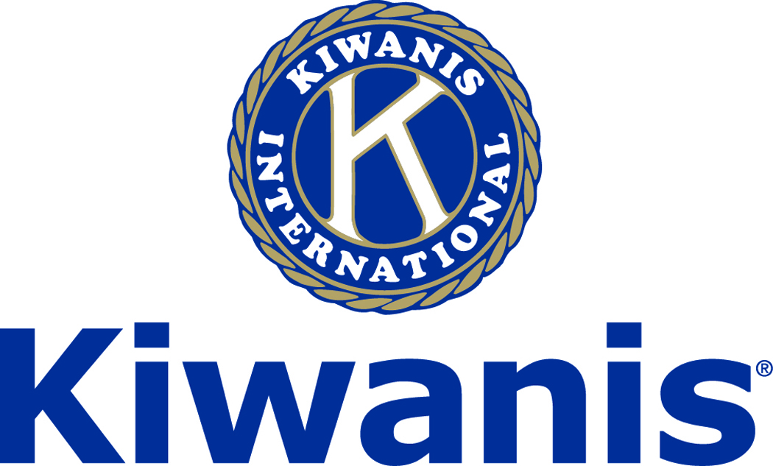

**Club of Las Vegas**

**Week of:**

**April 30, 2017**

[**http://www.kiwaniscluboflasvegas.org/**](http://www.kiwaniscluboflasvegas.org/)

******************************************************************

**SPEAKER for May 3, MEETING:**

**Sean Hoade:**

**Sean will speak about Ghostwriting for fun and profit**

**Networking: 11:45am. Meeting: 12:15 to 1:15pm.**

**Wednesday’s, Marie Callender's, 8175 West Sahara,**

**Lunch ($20) and includes a slice of pie.**

******************************************************************

**Win a free lunch!**

**Read this newsletter for details**

******************************************************************

**Last week at The Stratosphere Tower**

**The 26th Annual Educator of the Year**

**The Educator of the year program, now in its 26th year, was founded by the Kiwanis Club of Las Vegas in 1992 to recognize outstanding “Unsung Education Heroes” at the High School level in the Clark County School District (CCSD). This years finalists: William “Billy” Hemberger, Spring Valley HS, Joseph Juliano, Southwest CTA, Katherine “Katie” McShea, Shadow Ridge HS, Maggie Newman, Las Vegas HS, and Fran Bromley-Norwood, Cheyenne HS.**

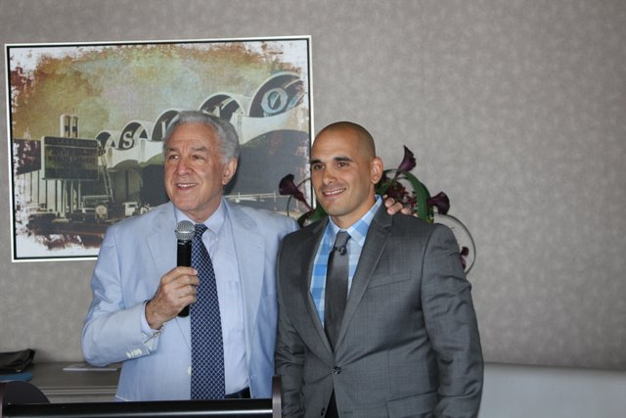

**The Educator of the Year for 2017 was William “Billy” Hemberger, Spring Valley HS.**

******************************************************************

**Coming May 26th Spring Social**

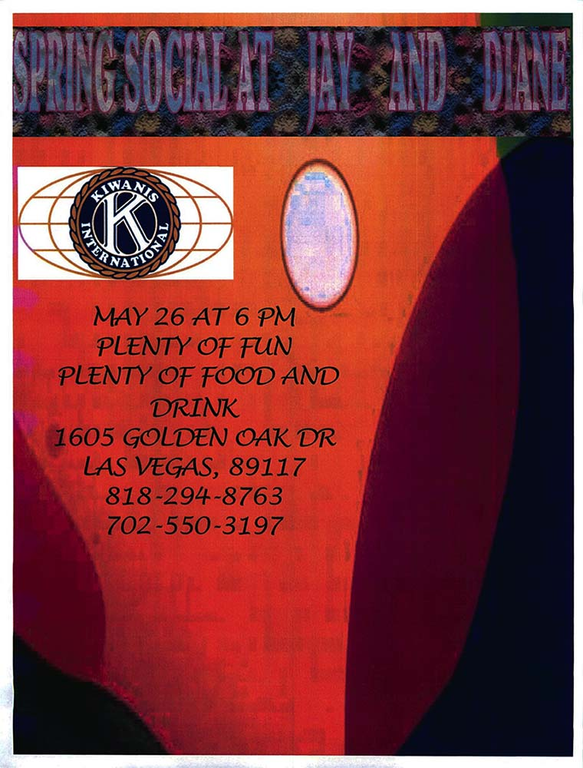

******************************************************************

**Use Amazon-Smile for your purchases.**

**When you do Amazon donates to**

**Kiwanis Club of Las Vegas Foundation**

**Please Use** [**smile.amazon.com**](https://smile.amazon.com/gp/r.html?C=7HYU8Y4EZWZW&R=2OM74E2TQH61W&T=C&U=http%3A%2F%2Fsmile.amazon.com%2Fgp%2Fcharity%2Fhomepage.html%3Forig%3D%252Fgp%252Fbrowse.html%253Fnode%253D502659011%26ein%3D86-0850741%26ref_%3Dpe_732550_190307700&A=I1HQ1LDYEOQFBAICG0TGN2IDZUOA&H=SYAUSO4VGWQXCXS3JTTAWZAJXWKA&ref_=pe_732550_190307700) and Amazon will donate to Kiwanis Club of Las Vegas Foundation. Sign up with Amazon Smile and designate the Kiwanis Club of Las Vegas Foundation as your charity. Amazon will donate 0.5% of the price of your eligible Amazon Smile purchases to Kiwanis Club of Las Vegas Foundation whenever you shop on Amazon Smile. Amazon Smile is the same Amazon you know. **Same products, Same prices, Same service**. Use the link below and you will be directed to great gift ideas and help support your Kiwanis Club of Las Vegas Foundation.  
  
**AmazonSmile click here:** [**smile.amazon.com/ch/86-0850741**](https://smile.amazon.com/gp/r.html?C=2AU9G2CMQ9IQM&R=2OM74E2TQH61W&T=C&U=http%3A%2F%2Fsmile.amazon.com%2Fch%2F86-0850741&A=6PNWEYXALJ7J4QHW7SL1FV6DH3KA&H=HK0LAEKSGAKLH10PCQ1PHTOGAMEA)

*******************************************************************

**Kiwanis Club of Las Vegas Elections**

**for 2017-2018 Kiwanis year will be May 10th**

**Be sure to attend the Wednesday, May 10th Kiwanis Club of Las Vegas meeting. This will be our annual meeting for elections for the Kiwanis Club of Las Vegas and the Kiwanis Club of Las Vegas Foundation.**

**Volunteers Needed.**

**If you are interested in becoming an officer or director, please contact ;**

**Dr. Phil Colosimo (**[**colosimo57@yahoo.com**](mailto:colosimo57@yahoo.com)**702-860-6088-C**

**702-453-5387-H  702-384-7433-W)**

**or**

**Len Yelinek (**[**lenyelinek@earthlink.net**](mailto:lenyelinek@earthlink.net)**702-362-7673-H  702-460-0769-C).**

**The list of nominees will be provided all members prior to the May 10th meeting.**

******************************************************************

**Buy Your Entertainment Book Today!**



Entertainment® is the North American leader in providing consumers significant savings on the things they love to do: dine, shop, travel and play. Consumers just like you have saved over $22 Billion since 1962 with discounts in the Entertainment® Book.

**We have a limited supply of Entertainment Books. Regular $30 now only $20.**

**See Howard Naylor to get your book!**

******************************************************************

**Coming Soon, Masters Golf Fundraiser**

**Watch for your opportunity to sign-up**

**Our Club will make money and it will NOT cost you anything, other than a few minutes of your time**

***Please help!***

******************************************************************

**Service Hours**

Be sure to turn in your service hours to Nancy Sapling

**Fill out the form at our weekly lunches or**

**Email Nancy at:** [**Nancy.Sapling7@gmail.com**](mailto:Nancy.Sapling7@gmail.com)

******************************************************************

**Donate to the**

***Kiwanis Club of Las Vegas Foundation***

**Help us fund our programs with your tax deductible donation to our Kiwanis Club of Las Vegas Foundation**

******************************************************************

FREE LUNCH!

**Each week we hold a random drawing**

**and one of our members wins a free lunch, including a slice of pie, redeemable at one of our next three regular meetings.**

***Congratulations’***

**>>>> Steve Trenshaw <<<<**

***You won a FREE Lunch***

**Redeem your free lunch at one of our next three meetings**

**May 3, 10, or 17 meeting!**

**See you there!**

******************************************************************

**You Can Make a Tax Free Donation to the**

***Kiwanis Club of Las Vegas Foundation***

The IRA Charitable Rollover is now permanent, allowing individuals aged 70 ½ or older to make a tax-free distribution from individual retirement accounts to the **Kiwanis Club of Las Vegas Foundation**, reducing their tax liability!

The Protecting Americans from Tax Hikes Act of 2015 has been signed into law. Among the many tax benefits made permanent was the IRA charitable transfer provision.

This provision allows individuals age 70½ or older to give up to $100,000 from their IRAs directly to qualified charities - such as the **Kiwanis Club of Las Vegas Foundation** - without having to pay income taxes on the distributions and the donations count as part of the IRA owner's RMD required annual withdrawal.

There's no tax deduction for the donated assets; however, they are not included as income, either. To qualify for this break, **the donation must be transferred directly from the IRA custodian to the Foundation and gifts for 2016 must be made by the year-end.**

Contact your financial advisor to find out how you may benefit from this new law.

******************************************************************

**UPCOMING May 2017 EVENTS:**

**May 3: -** Sean Hoade - Ghostwriting for fun and profit

**May 10: -** Teresa and Brian Bresee - Stop Bullying

**May 17: -** Michael Kling - Living Trusts

**May 24: -** TBA

**May 31: -** Billy Hemberger, 2017 Educator of the year, Spring Valley HS

*******************************************************************

**For club information Log onto our Web Site!**

[**http://www.kiwaniscluboflasvegas.org/**](http://www.kiwaniscluboflasvegas.org/)

**contact Jerry McElroy or Howard Naylor**

**with additions or corrections**

*******************************************************************