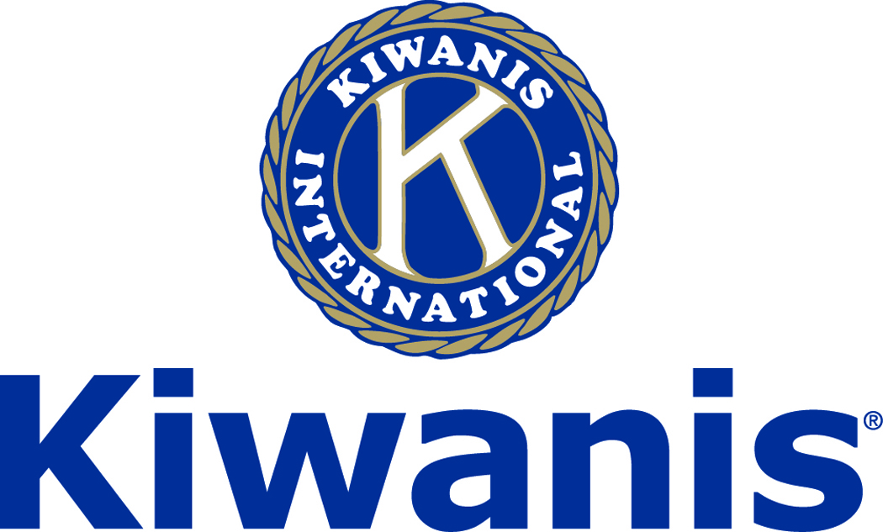
Club of Las Vegas

Week of:
July 1, 2018

******************************************************************

http://www.kiwaniscluboflasvegas.org/

******************************************************************
LAST WEEK

At our June 27th meeting Jay and Diane presented four Walter Zeller Fellowship Awards thanks to their donation to the Eliminate Project.

Thank You Diane Dieguez and Jay Schultz
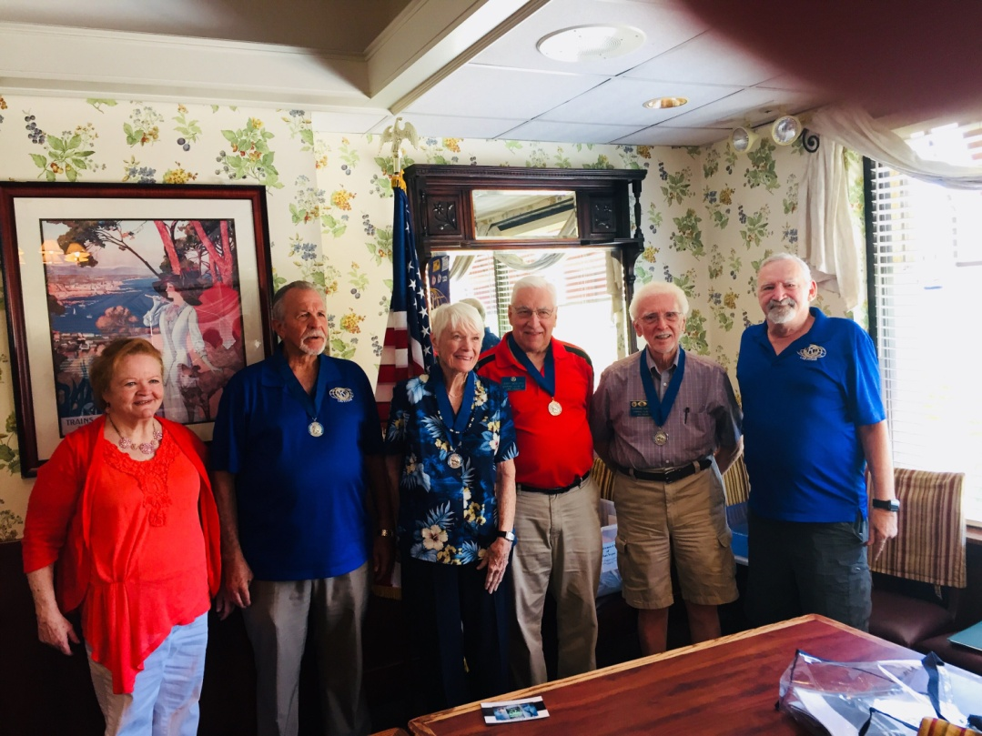
Diane Dieguez left and Jay Shultz right end

Len Yelinek, Nancy Sapling, Jerry McElroy and Howard Naylor
Received the Walter Zeller Fellowship award

******************************************************************

July 4: - NO MEETING

SPEAKER for July 11th MEETING:

Treena Chabot
A personal development coach specializing in mental health, a Playwright, and Theater Critic

Networking: 11:45am. Meeting: 12:15 to 1:15pm.

Wednesday’s, Marie Callender's, 8175 West Sahara,
Lunch ($20) and includes a slice of pie.

******************************************************************

Win a free lunch!
Read this newsletter for details

******************************************************************
Register for the Cal-Nev-Ha District Convention!

2018 Cal-Nev-Ha District Convention
August 9-11, 2018
Sheraton Kona Resort & Spa, Kona, Hawaii
District Convention Information

******************************************************************
International Convention
Business Session Results are In!
Election Results are In!:
The delegates at the 103rd Annual Kiwanis International Convention elected the following Kiwanians Friday June 29th to lead the 2018-2019 year:
International President: Florencio C. "Poly" Lat, Metro Manila, Philippines
International President-elect: Daniel Vigneron, Howald, Luxembourg
International Vice-president:
Arthur N. Riley, Westminster, Maryland
International Trustee:
Katrina J. Baranko, Albany, Georgia
George R. Delisle, Westfield, Massachusetts
Ronald E. Smith, Fountain Hills, Arizona
Congratulations to all of the elected leaders!

Amendment Results are In!:
These are the results of the proposed amendments from the House of Delegates during the 103rd Annual Kiwanis International Convention:
Proposed Amendment 1: District Board Endorsement of Kiwanis International Board Candidates - Adopted
Proposed Amendment 2: Timing of Kiwanis International Candidate Announcements - Adopted (as amended)

Proposed Amendment 3: Family Membership Status - Defeated

******************************************************************

Service Hours
Be sure to turn in your service hours to Nancy Sapling

Fill out the form at our weekly lunches or
Email your service hours to Nancy at: Nancy.Sapling7@gmail.com

******************************************************************
Please Use Amazon-Smile
Select Kiwanis Club of Las Vegas Foundation as your charity when making your purchases.

When you order at Amazon-Smile, Amazon donates to
Kiwanis Club of Las Vegas Foundation
This year we’ve received $184.33

Use smile.amazon.com and Amazon will donate to Kiwanis Club of Las Vegas Foundation. Sign up with Amazon Smile and designate the Kiwanis Club of Las Vegas Foundation as your charity. Amazon will donate 0.5% of the price of your eligible Amazon Smile purchases to Kiwanis Club of Las Vegas Foundation whenever you shop on Amazon Smile. Amazon Smile is the same Amazon you know. Same products, Same prices, Same service. Use the link below and you will be directed to great gift ideas and help support your Kiwanis Club of Las Vegas Foundation.
AmazonSmile click here: smile.amazon.com/ch/86-0850741

******************************************************************

Donate to the
Kiwanis Club of Las Vegas Foundation
a 501(c)(3) charitable organization

Help us fund our programs with your tax deductible donation to our Kiwanis Club of Las Vegas Foundation

******************************************************************

FREE LUNCH!

Each week we hold a random drawing
and one of our members wins a free lunch, including a slice of pie, redeemable at one of our next three regular meetings.

Congratulations’
>>>> Kevin Page <<<<
You won a FREE Lunch

Redeem your free lunch at one of our next three meetings
July 11th, 18th or 25th meeting!

*******************************************************************

Save your POP-TABS to benefit
Ronald Mc Donald House

If you have pop tabs to donate contact Len Yelinek.

******************************************************************

UPCOMING June 2018 EVENTS

June 27: - Paul Atreides, Author, Playwright and theater critic

July 4: - NO MEETING

July 11: - Treena Chabot , a personal development coach specializing in mental health
July 18: - TBA
July 25: - Dean Barbara Atkinson of the UNLV School of Medicine

*******************************************************************

For club information Log onto our Web Site!

You can make a donation to our club on our web home page.

http://www.kiwaniscluboflasvegas.org/

contact Jerry McElroy or Howard Naylor
with additions or corrections

******************************************************************

