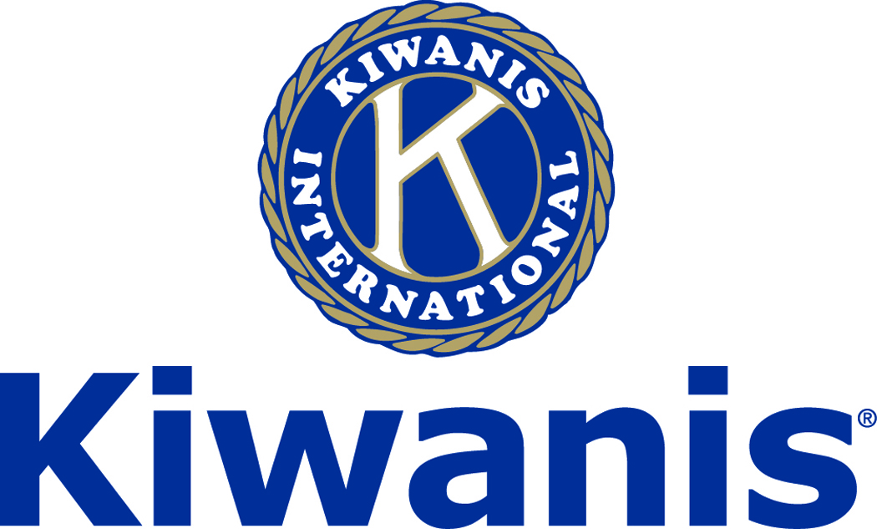
Club of Las Vegas

Week of:
April 1, 2018
http://www.kiwaniscluboflasvegas.org/

******************************************************************

SPEAKER for April 4th MEETING:

Debbie Donaldson
"Power up your life"

Networking: 11:45am. Meeting: 12:15 to 1:15pm.

Wednesday’s, Marie Callender's, 8175 West Sahara,
Lunch ($20) and includes a slice of pie.

******************************************************************
Watch Varsity Quiz Monday’s at 7:30PM on TV Channel 10.

******************************************************************

Educator of the Year
April 18th
Sign Up and Pre-Pay now
Gourmet Lunch $30

Please, RSVP and Pre-Pay for this event sorry no walk in’s. The Educator of the year program, now in its 27th year, was founded by the Kiwanis Club of Las Vegas in 1992 to recognize outstanding “Unsung Education Heroes” at the High School level in the Clark County School District (CCSD).

The program was the brainchild of Kiwanian Ned L. Jacobs, who had been Director of Kaplan Education Corporation in San Diego before becoming Executive Director of the Lied Children’s Discovery Museum in Las Vegas. The Educator of the Year Awards lunch will be at the Stratosphere Tower April 18th. Lunch is $30 please RSVP and pay in advance.

******************************************************************

Kiwanis Club of Las Vegas Elections
for 2018-2019 Kiwanis year coming soon
Contact President John Case for information

******************************************************************

Varsity Quiz

Playoff games are now being broadcast on Channel 10 on Mondays at 7:30PM. This is the 49th season of Varsity Quiz. The Varsity Quiz Program is patterned after a high school program that was being sponsored by the Kiwanis Club of Greater Anaheim. In 1969 a delegation from that club convinced the leadership of the Kiwanis Club of Las Vegas to sponsor a similar program in Clark County. The Southern Nevada program was named Varsity Quiz. It is conducted within the Clark County School District (CCSD). The Varsity Quiz Program is a partnership between the Kiwanis Club of Las Vegas, CCSD, and Vegas PBS TV-10.

******************************************************************

Win a free lunch!
Read this newsletter for details

******************************************************************

Donate to the
Kiwanis Club of Las Vegas Foundation
a 501(c)(3) charitable organization

Help us fund our programs with your tax deductible donation to our Kiwanis Club of Las Vegas Foundation

******************************************************************

Save your POP-TABS to benefit
Ronald Mc Donald House

If you have pop tabs to donate contact Len Yelinek.

******************************************************************

Please Use Amazon-Smile
Select Kiwanis Club of Las Vegas Foundation as your charity when making your purchases.

When you order at Amazon-Smile, Amazon donates to
Kiwanis Club of Las Vegas Foundation
This year we’ve received $170.52

Use smile.amazon.com and Amazon will donate to Kiwanis Club of Las Vegas Foundation. Sign up with Amazon Smile and designate the Kiwanis Club of Las Vegas Foundation as your charity. Amazon will donate 0.5% of the price of your eligible Amazon Smile purchases to Kiwanis Club of Las Vegas Foundation whenever you shop on Amazon Smile. Amazon Smile is the same Amazon you know. Same products, Same prices, Same service. Use the link below and you will be directed to great gift ideas and help support your Kiwanis Club of Las Vegas Foundation.
AmazonSmile click here: smile.amazon.com/ch/86-0850741

******************************************************************

FREE LUNCH!

Each week we hold a random drawing
and one of our members wins a free lunch, including a slice of pie, redeemable at one of our next three regular meetings.

Congratulations’
>>>> Vernon Bailey <<<<
You won a FREE Lunch

Redeem your free lunch at one of our next three meetings
April 4th, 11th or 25th meeting!

*******************************************************************

Service Hours
Be sure to turn in your service hours to Nancy Sapling

Fill out the form at our weekly lunches or
Email your service hours to Nancy at: Nancy.Sapling7@gmail.com

******************************************************************

UPCOMING April 2018 EVENTS

April 4: - Debbie Donaldson "Power up your life"
April 11: - Becky Mintz “The importance of organ donation”
April 18: - Kiwanis “Educator of the year”
April 25: - John Perdichizzi “ADT Security”

*******************************************************************

For club information Log onto our Web Site!

You can make a donation to our club on our web home page.

http://www.kiwaniscluboflasvegas.org/

contact Jerry McElroy or Howard Naylor
with additions or corrections

******************************************************************

